National Kick-off meeting minutes

4th March 2025

University of Montenegro, Rectorate

List of participants

Prof. dr Ramo Šendelj, University of Donja Gorica, Montenegro
Prof. dr Ivana Ognjanović, University of Donja Gorica, Montenegro
mr Luka Laković, University of Donja Gorica, Montenegro
Jelena Terzić, University of Montenegro, Montenegro
Lidija Milosavljević, University of Montenegro, Montenegro
Nataša Gospić, University Adriatik Bar, Montenegro (ONLINE)
Oliver Popović, University Adriatik Bar, Montenegro (ONLINE)
Milena Ljutica, Institute of Modern Technologies of Montenegro, Montenegro
Tanja Radusinović, Chamber of Economy Montenegro, Montenegro
Nada Rakočević, Chamber of Economy Montenegro, Montenegro
Ana Rutović, Agency for Control and Quality Assurance of Higher Education, Montenegro

Total number of participants: 9 on-sight, 2 online, from 6 institutions

Meeting was organised in “White Hall” at the University of Montenegro via ZOOM video conference system for the partners who could not attend on-sight, and started at 10h.

Attendees were welcomed by Jelena Terzić from the Rectorate of the University of Montenegro and agenda was introduced by prof. dr Ramo Šendelj, who has made a brief overview of the ongoing project task and desired dynamics of project activities.
The discussion ensued regarding the various requirements for the successful completion of Task 2.2. Methodology implementation: analysis of vulnerabilities and risks, mapping of existing capacities and resources in terms of both integral review of Higher Education system in Montenegro and individual profiles of each partner institution. Further on, joint discussion helped to organize future document in two blocks, review of all four universities in one block and other four partner institutions who are stakeholders in the sphere of higher education in the other.
In consideration of the need for results to be aligned with best practice standards, the Coordinator has proposed a concept of template for survey of Montenegrin partner institutions, which shall ensure streamlined inputs by each partner institution.

Internal dynamic for submission by project partners has been established.

Prof. dr Ivana Ognjanović has moderated a discussion regarding the Task 10.4. 1st number of Online newsletter “Cyber Security for all”, and editorial and design issues. University of Mediterranean, Podgorica has taken on the design of the first digital issue.

Further item on agenda for today was Event 2.1 from the Application Experience and knowledge transfer: CSIRT Poland, and travel arrangements are to be finalized in the next week.
Number of attendees per project partners: AGH(4), UDG(3), UOM(2), UNIM(1), AUB(1), MEdu(2), IMTM(1), PKCG(1), ACQAHE (1).

Effective communication and cooperation between partners proves to be of great benefit for project results. Further inputs from coordinators shall follow up in the coming days.

Meeting ended at 12.15h.

To do list by activities:

Action | Partners | Due Date
WP2. Task 2.2 Methodology implementation: analysis of vulnerabilities and risks, mapping of existing capacities and resources | MNE partner institutions | 20th April 2025  (internal deadline 31st March 2025)
WP10. Task 10.4 Online newsletter “Cyber Security for all” 1st number | PKCG  UNIM | 31st March 2025
E 2.1 Experience and knowledge transfer: Visit to CSIRT Poland | AGH + MNE partner instutions | April 2025  (to be defined soon)

Photos:

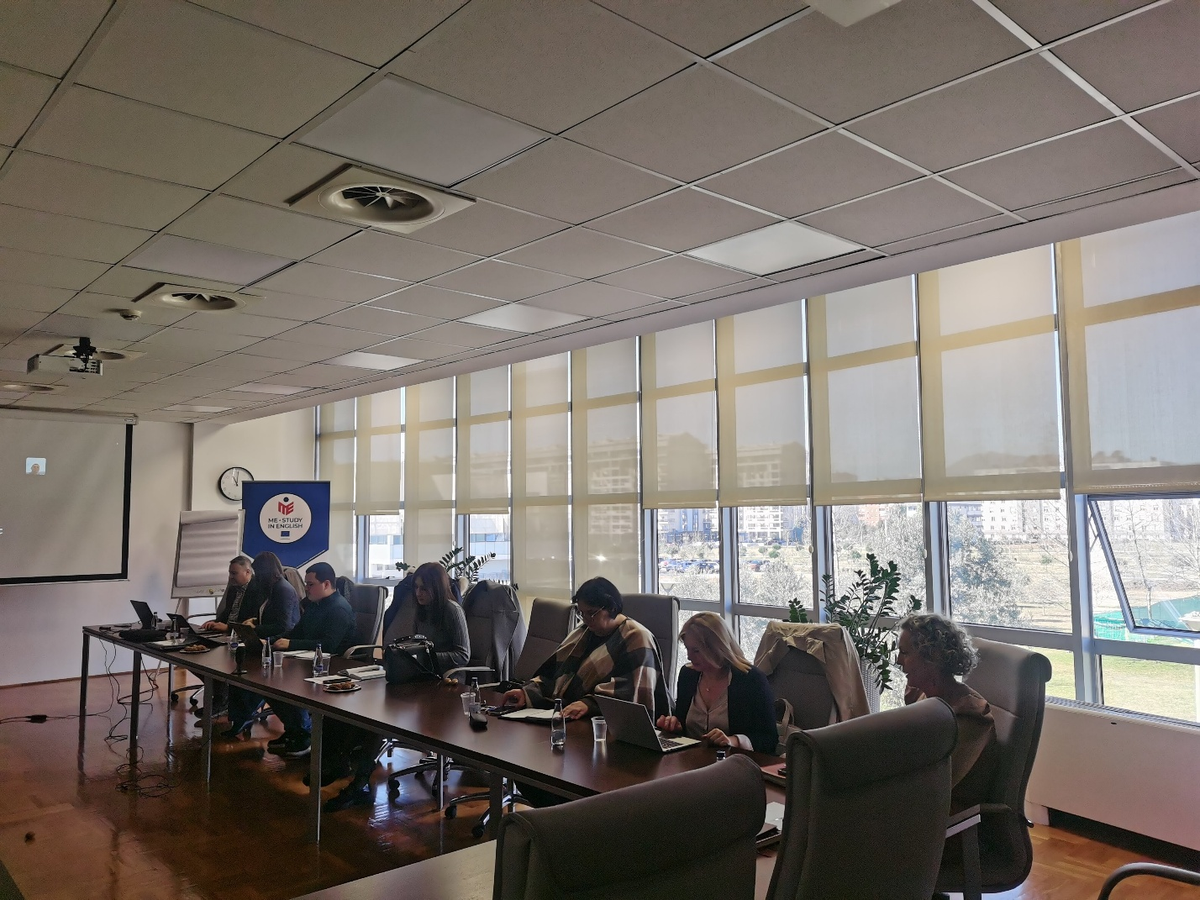

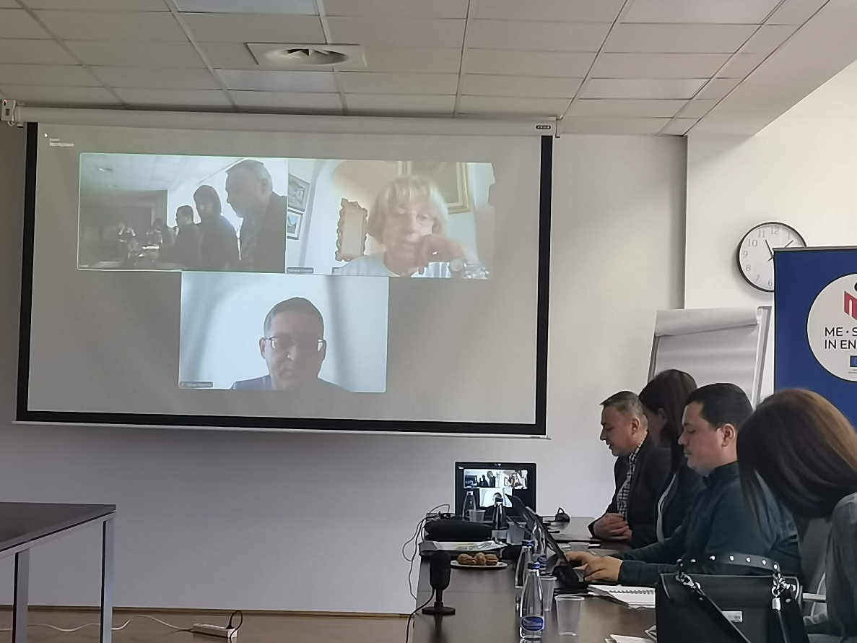
On-site and online attendees (zoom)
